Multi-Developer Database Development Workflow
for Plasmit Hospital Management System

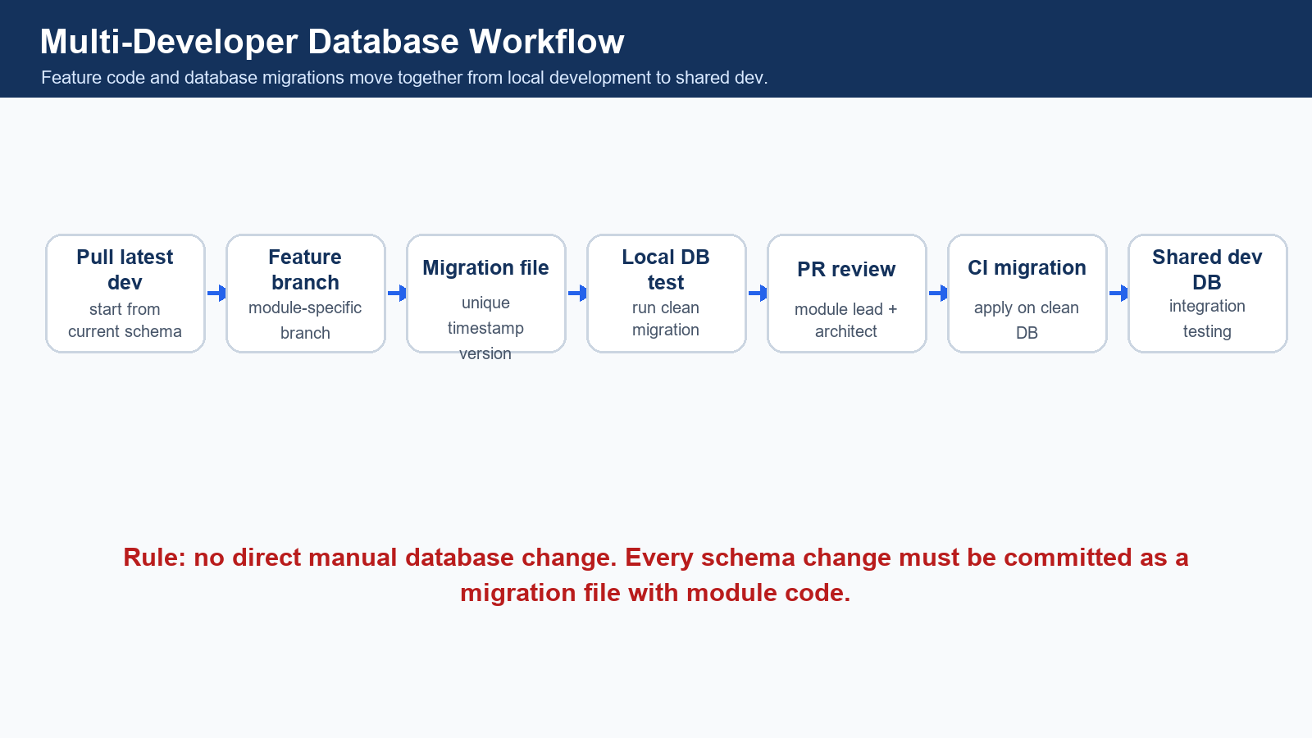
End-to-end workflow for multiple database developers.
Prepared For | Technology Stack | Recommended Tool | Document Purpose
Backend, database, integration and QA teams | Spring Boot, Java 17, MySQL, JDBC/NamedParameterJdbcTemplate | Flyway | Allow 8-12 developers to build database and backend modules without conflicts

Table of Contents
- 1. Executive Summary
- 2. Core Rules for All Developers
- 3. Team Distribution Model
- 4. Database Ownership Matrix
- 5. Recommended Table Prefix Strategy
- 6. Standard Columns for Every Table
- 7. Migration File Workflow
- 8. Migration Folder Structure
- 9. Git Branching Strategy
- 10. Commit Message Convention
- 11. Pull Request Checklist
- 12. Database Review Process
- 13. Conflict Prevention Rules
- 14. Local Development Database Strategy
- 15. Seed Data Strategy
- 16. Tenant Isolation Rules
- 17. FHIR and HL7 Responsibility Distribution
- 18. Inter-Module Dependency Flow
- 19. Developer Daily Workflow
- 20. Integration Testing Workflow
- 21. Database Documentation Process
- 22. Example Module Distribution Plan
- 23. Definition of Done
- 24. Anti-Patterns to Avoid
- 25. Final Recommended Workflow Summary

1. Executive Summary
This workflow defines how multiple backend and database developers should work together while building the Plasmit Hospital Management System database. The platform uses Spring Boot microservices, MySQL, Java 17, JDBC or NamedParameterJdbcTemplate, Flyway migrations, and strict multi-tenant isolation using tenant_id, hospital_id and branch_id.
Why this workflow is mandatory
- Without migration control, developers can overwrite each other's schema changes.
- Without ownership, two teams may create duplicate tables for the same business concept.
- Without tenant filters, one hospital or branch can accidentally see another hospital's data.
- Without review, FHIR, HL7, reporting and audit mappings become inconsistent.
- Migration versioning creates a reliable history of schema changes and makes deployment repeatable.


Recommended multi-developer database workflow.

2. Core Rules for All Developers
- Never directly alter the shared database manually.
- Every table, column, index, trigger or constraint change must go through a migration file.
- Every major table must include tenant_id, hospital_id and branch_id where applicable.
- Every table must include audit columns: created_by, updated_by, created_at, updated_at, is_deleted.
- Every query must filter by tenant_id, hospital_id and branch_id where applicable.
- Every module developer owns only their assigned module tables.
- Shared master tables require database architect approval.
- Do not duplicate existing tables or create random naming.
- Do not remove or rename columns without migration and review approval.
- Do not add FHIR or HL7 mapping randomly without integration team review.
- Never edit an already merged Flyway migration.
- Every migration must be committed with related repository, service and API code.

3. Team Distribution Model
Coverage update
- Developer C now owns the full clinical core: OPD, doctor workbench, EMR, vitals, diagnosis, allergy, care plan, clinical orders and prescription.
- Developer L has been added for hospital operations modules: HRMS, staff attendance, store, procurement, diet, housekeeping, maintenance, helpdesk and portals.
- The ownership matrix below covers clinical, operational, financial, integration, reporting and compliance modules.

Developer | Owned Modules | Owned Tables | Dependent Modules | Migration Ownership | API Testing Responsibility | Review Dependency
Developer A | SaaS Foundation / Tenant / Hospital / Branch / Department / User / Role / Permission | tenants, subscriptions, hospitals, branches, departments, healthcare_services, users, roles, permissions, user_branch_access | All modules | Foundation and access-control migrations | Auth, tenant setup, hospital setup, branch setup, RBAC APIs | Database Architect + Security Lead
Developer B | Patient Registration / MPI / Patient Contacts / Patient Documents / Appointment / Queue | patients, patient_identifiers, patient_addresses, patient_contacts, patient_documents, appointments, appointment_slots, appointment_queues, appointment_status_history | Foundation, Clinical, Billing, Lab, Pharmacy | Patient and appointment migrations | Registration, MPI search, appointment, queue, patient document APIs | Foundation + Clinical + FHIR team
Developer C | Complete Clinical Core / OPD / Doctor Workbench / EMR / Vitals / Diagnosis / Allergy / Care Plan / Clinical Orders / Prescription | doctors, doctor_schedules, encounters, encounter_participants, clinical_notes, emr_documents, vitals, diagnoses, problem_lists, patient_allergies, care_plans, clinical_orders, prescriptions, prescription_items | Patient, Appointment, Lab, Radiology, Pharmacy, Billing | Clinical and prescription migrations | Doctor workbench, OPD, EMR, vitals, diagnosis, allergy, care plan, prescription APIs | Patient + Diagnostics + Pharmacy + FHIR team
Developer D | Lab / Diagnostics / Sample Collection / Result Entry / Critical Alerts / Radiology / Imaging Reports | lab_orders, lab_order_items, lab_samples, lab_results, lab_result_flags, diagnostic_reports, radiology_orders, radiology_reports, radiology_images | Patient, Encounter, Billing, FHIR/HL7 | Lab and radiology migrations | Lab order, token/queue, sample, result, radiology report APIs | Clinical + Billing + FHIR/HL7 team
Developer E | Pharmacy / Medicine Master / Batch / Stock / Prescription Dispensing / Sales / Returns | medicines, medicine_categories, medicine_batches, pharmacy_stock, pharmacy_stock_movements, pharmacy_sales, pharmacy_sale_items, pharmacy_returns, medication_dispenses | Prescription, Billing, Inventory | Pharmacy migrations | Medicine master, stock, low-stock, expiry, dispensing, sales APIs | Clinical + Billing + FHIR team
Developer F | Billing / Invoicing / Payments / Refunds / Package Billing / Insurance / TPA / Claims | billing_invoices, billing_invoice_items, billing_packages, payments, payment_allocations, refunds, insurance_policies, insurance_claims, claim_documents, claim_status_history | Patient, Encounter, Lab, Radiology, Pharmacy, IPD | Billing, payment and insurance migrations | Invoice, payment, refund, package, claim, receipt APIs | Architect + Reporting + Integration team
Developer G | IPD / Admission / Ward / Room / Bed / Nursing / Medication Administration / Discharge Summary | admissions, admission_transfers, wards, rooms, beds, bed_allocations, nursing_notes, nursing_tasks, medication_administrations, discharge_checklists, discharge_summaries, followups | Patient, Encounter, Clinical, Billing | IPD, nursing and discharge migrations | Admission, transfer, bed, nursing, MAR, discharge, follow-up APIs | Clinical + Billing + FHIR team
Developer H | Emergency / ER / Triage / Surgery / OT / Ambulance / Blood Bank | emergency_cases, triage_assessments, emergency_orders, surgeries, operation_theatres, surgery_team, surgery_checklists, anesthesia_records, ambulance_requests, blood_donors, blood_bank_units, blood_transfusions | Patient, Encounter, Clinical, Billing, Inventory | Emergency, OT, ambulance and blood bank migrations | ER queue, triage, OT, surgery, ambulance, blood bank APIs | Clinical + Billing + Architect
Developer I | FHIR Gateway / HL7 Integration / External System Mapping / Identifier Mapping | fhir_resource_mapping, fhir_resource_store, fhir_api_audit_log, fhir_sync_status, fhir_code_system_mapping, hl7_message_log, hl7_message_error_log, hl7_mapping, external_identifier_mapping, integration_endpoints | All clinical, billing, patient and master modules | FHIR, HL7 and integration migrations | FHIR API, HL7 inbound/outbound, mapping, replay and partner integration tests | Architect + Module Owners
Developer J | Reporting / Dashboard / Denormalized Summary Tables / Analytics / AI Patient Journey Command Center | daily_branch_revenue_summary, daily_patient_visit_summary, department_wise_collection_summary, doctor_performance_summary, lab_test_volume_summary, pharmacy_stock_snapshot, bed_occupancy_summary, patient_journey_summary, ai_alerts | All modules | Reporting and analytics migrations | Dashboard, summary refresh, command center, AI alert data APIs | Architect + Module Owners + Compliance
Developer K | Audit / Compliance / Consent / Notification / Security Logs / Access Logs | audit_logs, user_login_history, patient_record_access_logs, consent_records, break_glass_access_logs, notifications, notification_templates, notification_delivery_logs, security_events | All modules | Audit, compliance and notification migrations | Audit, access log, consent, notification, security event APIs | Security Lead + Compliance + Architect
Developer L | Hospital Operations / HRMS / Staff Attendance / Store Inventory / Procurement / Diet Kitchen / Housekeeping / Maintenance / Helpdesk / Patient Portal / Doctor Portal | staff_profiles, staff_attendance, staff_shifts, inventory_items, store_stock, stock_requisitions, purchase_orders, purchase_order_items, goods_receipts, vendor_master, diet_orders, kitchen_menus, housekeeping_tasks, maintenance_tickets, helpdesk_tickets, portal_users, portal_sessions | Foundation, Billing, IPD, Pharmacy, Patient | Operations, HRMS, inventory, procurement, portal migrations | Staff attendance, inventory, purchase, diet, housekeeping, maintenance, helpdesk, patient portal and doctor portal APIs | Hospital Admin + Billing + Security + Architect

4. Database Ownership Matrix
Module | Table Prefix | Owner | Primary Tables | Shared Dependencies | FHIR Resources | Review Required From
Super Admin / SaaS Admin | tenant_, subscription_ | Developer A | tenants, subscription_plans, tenant_subscriptions, tenant_settings | None | Organization | Architect
Tenant / Hospital Group Admin | tenant_, hospital_ | Developer A | tenants, hospitals, hospital_groups, tenant_admin_users | SaaS foundation | Organization | Architect
Hospital Setup | hospital_ | Developer A | hospitals, healthcare_services, hospital_settings, hospital_documents | Tenant | Organization, HealthcareService, DocumentReference | Architect + Compliance
Branch / Facility Management | branch_, location_ | Developer A | branches, branch_locations, counters, branch_settings | Hospital | Location | Architect
Department Management | department_, service_ | Developer A | departments, department_services, service_catalog | Hospital, Branch | HealthcareService | Architect
User / Role / Permission | user_, role_, permission_ | Developer A | users, roles, permissions, role_permissions, user_branch_access, practitioner_roles | Hospital, Branch | Practitioner, PractitionerRole | Security Lead
Patient Registration / MPI | patient_ | Developer B | patients, patient_identifiers, patient_addresses, patient_contacts, patient_merge_history | Foundation | Patient, RelatedPerson | Foundation + FHIR team
Patient Documents | patient_document_, document_ | Developer B | patient_documents, documents, document_versions, document_access_logs | Patient, Encounter | DocumentReference | Clinical + FHIR team
Patient Portal | portal_ | Developer L | portal_users, portal_sessions, portal_patient_links, portal_document_access | Patient, Auth, Documents | Patient, DocumentReference | Security + Patient team
Doctor Portal | doctor_portal_ | Developer L | doctor_portal_profiles, doctor_portal_sessions, doctor_task_views | Doctor, Clinical, Appointment | Practitioner, Encounter | Security + Clinical team
Appointment Scheduling | appointment_ | Developer B | appointments, appointment_slots, appointment_queues, appointment_status_history, appointment_reminders | Patient, Users, Branch | Appointment | Foundation + Notification team
Encounter / Visit | encounter_ | Developer C | encounters, encounter_participants, encounter_status_history, encounter_locations | Patient, Appointment, Branch, Doctor | Encounter | Patient + Clinical team
OPD Management | opd_ | Developer C | opd_visits, opd_queue, doctor_consultations, consultation_status_history | Patient, Appointment, Encounter | Encounter, Observation, Condition | Patient + FHIR team
Doctor Workbench | doctor_, clinical_ | Developer C | doctor_schedules, doctor_tasks, clinical_orders, doctor_review_queue | Encounter, Lab, Radiology, Prescription | PractitionerRole, ServiceRequest | Clinical Lead
Clinical Notes / EMR | clinical_, emr_ | Developer C | clinical_notes, emr_documents, progress_notes, procedure_notes, discharge_clinical_notes | Encounter, Doctor | DocumentReference, Composition | FHIR team
Vitals and Observation | vital_, observation_ | Developer C | vitals, observation_records, nursing_observations, growth_charts | Encounter, Nursing | Observation | Clinical + FHIR team
Diagnosis / Problem List | diagnosis_, problem_ | Developer C | diagnoses, problem_lists, diagnosis_status_history | Encounter, Doctor | Condition | Clinical + FHIR team
Allergy / Immunization / Care Plan | allergy_, immunization_, care_plan_ | Developer C | patient_allergies, immunizations, care_plans, care_plan_goals | Patient, Encounter | AllergyIntolerance, Immunization, CarePlan | FHIR team
Prescription / Medication Order | prescription_, medication_order_ | Developer C | prescriptions, prescription_items, medication_orders, medication_order_status_history | Encounter, Pharmacy | MedicationRequest | Pharmacy + FHIR team
Nursing Module | nursing_ | Developer G | nursing_notes, nursing_tasks, nursing_handover, medication_administrations, fluid_balance_records | IPD, Encounter, Clinical | Observation, MedicationAdministration | Clinical + FHIR team
IPD / Admission Management | admission_, ipd_ | Developer G | admissions, admission_transfers, ipd_rounds, ipd_care_team | Patient, Encounter, Ward | Encounter | Clinical + Billing
Ward / Room / Bed Management | ward_, room_, bed_ | Developer G | wards, rooms, beds, bed_allocations, bed_transfer_history | Branch, IPD | Location | Hospital Admin
Discharge Summary | discharge_ | Developer G | discharge_checklists, discharge_summaries, discharge_medications, followups | IPD, Clinical, Billing | DocumentReference, CarePlan | Clinical + Billing + FHIR
Lab / Diagnostics | lab_ | Developer D | lab_orders, lab_order_items, lab_samples, lab_results, lab_result_flags, diagnostic_reports | Encounter, Billing | ServiceRequest, Observation, DiagnosticReport | FHIR/HL7 team
Radiology / Imaging | radiology_ | Developer D | radiology_orders, radiology_reports, radiology_images, radiology_report_reviews | Encounter, Billing | ServiceRequest, DiagnosticReport, ImagingStudy | FHIR/HL7 team
Pharmacy Master / Inventory | medicine_, pharmacy_stock_ | Developer E | medicines, medicine_categories, medicine_batches, pharmacy_stock, pharmacy_stock_movements | Hospital, Branch, Store | Medication | Inventory + FHIR team
Pharmacy Sales / Dispensing | pharmacy_sale_, medication_dispense_ | Developer E | pharmacy_sales, pharmacy_sale_items, pharmacy_returns, medication_dispenses | Prescription, Billing, Stock | MedicationDispense | Billing + FHIR team
Billing / Invoicing | billing_ | Developer F | billing_invoices, billing_invoice_items, billing_packages, charge_master, patient_accounts | Patient, Encounter, Services | Account, ChargeItem | Architect + Reporting
Payment / Refunds | payment_, refund_ | Developer F | payments, payment_allocations, refunds, receipt_print_logs | Billing | ExplanationOfBenefit | Finance Lead
Insurance / TPA / Claims | insurance_, claim_ | Developer F | insurance_policies, insurance_claims, claim_documents, claim_status_history, tpa_master | Billing, Patient | Coverage, Claim, ExplanationOfBenefit | Architect + Integration
Emergency / ER | emergency_, triage_ | Developer H | emergency_cases, triage_assessments, emergency_orders, emergency_transfer_logs | Patient, Encounter, Billing | Encounter, Observation, ServiceRequest | Clinical + Billing
OT / Surgery Management | surgery_, ot_ | Developer H | surgeries, operation_theatres, surgery_team, surgery_checklists, anesthesia_records | Encounter, Billing, Inventory | Procedure | Clinical + Architect
Ambulance | ambulance_ | Developer H | ambulances, ambulance_requests, ambulance_trips, ambulance_staff_assignments | Patient, Emergency, Billing | Encounter, Location | Operations + Billing
Blood Bank | blood_ | Developer H | blood_donors, blood_bank_units, blood_requests, blood_transfusions, blood_screening_results | Patient, Lab, Billing | Observation, Procedure | Clinical + Compliance
Staff Attendance / HRMS | staff_, attendance_ | Developer L | staff_profiles, staff_attendance, staff_shifts, leave_requests, payroll_references | Users, Branch | Practitioner | HR + Security
Inventory / Store | inventory_, store_ | Developer L | inventory_items, store_stock, stock_requisitions, stock_issues, stock_adjustments | Branch, Pharmacy, Surgery | N/A | Hospital Admin + Finance
Procurement / Purchase | purchase_, vendor_ | Developer L | vendor_master, purchase_orders, purchase_order_items, goods_receipts, supplier_invoices | Inventory, Billing | N/A | Finance + Store
Diet / Kitchen | diet_, kitchen_ | Developer L | diet_orders, diet_plans, kitchen_menus, meal_delivery_logs | IPD, Patient | NutritionOrder | Clinical + Operations
Housekeeping | housekeeping_ | Developer L | housekeeping_tasks, cleaning_schedules, bed_cleaning_logs | Ward, Bed, Branch | N/A | Operations
Maintenance | maintenance_ | Developer L | maintenance_tickets, asset_maintenance_logs, equipment_downtime_logs | Inventory, Branch | Device | Operations + Biomedical
Helpdesk / Support | helpdesk_ | Developer L | helpdesk_tickets, support_categories, ticket_comments, ticket_sla_logs | Users, Branch | N/A | Operations
Notification System | notification_ | Developer K | notifications, notification_templates, notification_delivery_logs, notification_preferences | All modules | Communication | Security + Module Owners
Audit / Compliance / Consent | audit_, consent_, access_ | Developer K | audit_logs, user_login_history, patient_record_access_logs, consent_records, break_glass_access_logs, security_events | All modules | AuditEvent, Consent | Compliance + Security
FHIR API Layer | fhir_ | Developer I | fhir_resource_mapping, fhir_resource_store, fhir_api_audit_log, fhir_sync_status, fhir_code_system_mapping | All mapped modules | All mapped resources | Architect + Module Owners
HL7 Integration | hl7_ | Developer I | hl7_message_log, hl7_message_error_log, hl7_mapping, hl7_ack_log, integration_endpoints | Patient, Lab, Radiology, Billing | N/A | Integration Lead
Reporting / Dashboard | summary_, report_ | Developer J | daily_branch_revenue_summary, daily_patient_visit_summary, department_wise_collection_summary, doctor_performance_summary, lab_test_volume_summary, bed_occupancy_summary | All modules | N/A | Architect + Module Owners
AI Patient Journey Command Center | ai_, journey_ | Developer J | patient_journey_summary, ai_alerts, operational_risk_scores, journey_stage_events | Patient, Encounter, Lab, Pharmacy, Billing, Discharge | N/A | Clinical + Compliance + Architect

5. Recommended Table Prefix Strategy
Area | Recommended Names
SaaS/foundation | tenants, subscription_plans, tenant_subscriptions, hospitals, branches, departments, healthcare_services
Security/access | users, roles, permissions, role_permissions, user_branch_access, practitioner_roles
Patient/MPI | patients, patient_identifiers, patient_addresses, patient_contacts, patient_merge_history
Portals | portal_users, portal_sessions, portal_patient_links, doctor_portal_profiles
Appointment/queue | appointments, appointment_slots, appointment_queues, appointment_status_history
Encounter/visit | encounters, encounter_participants, encounter_status_history, encounter_locations
OPD/doctor workbench | opd_visits, opd_queue, doctor_consultations, doctor_tasks, clinical_orders
Clinical/EMR | clinical_notes, emr_documents, progress_notes, diagnoses, problem_lists, vitals, observation_records
Allergy/care plan | patient_allergies, immunizations, care_plans, care_plan_goals
Prescription | prescriptions, prescription_items, medication_orders, medication_order_status_history
Nursing | nursing_notes, nursing_tasks, nursing_handover, medication_administrations, fluid_balance_records
Lab/diagnostics | lab_orders, lab_order_items, lab_samples, lab_results, lab_result_flags, diagnostic_reports
Radiology/imaging | radiology_orders, radiology_reports, radiology_images, radiology_report_reviews
Pharmacy | medicines, medicine_categories, medicine_batches, pharmacy_stock, pharmacy_stock_movements, pharmacy_sales, pharmacy_sale_items
Billing | billing_invoices, billing_invoice_items, billing_packages, charge_master, patient_accounts
Payment/refund | payments, payment_allocations, refunds, receipt_print_logs
Insurance/TPA | insurance_policies, insurance_claims, claim_documents, claim_status_history, tpa_master
IPD/ward/bed | admissions, admission_transfers, wards, rooms, beds, bed_allocations, bed_transfer_history
Discharge/follow-up | discharge_checklists, discharge_summaries, discharge_medications, followups
Emergency/ER | emergency_cases, triage_assessments, emergency_orders, emergency_transfer_logs
Surgery/OT | surgeries, operation_theatres, surgery_team, surgery_checklists, anesthesia_records
Ambulance | ambulances, ambulance_requests, ambulance_trips, ambulance_staff_assignments
Blood bank | blood_donors, blood_bank_units, blood_requests, blood_transfusions, blood_screening_results
HRMS/attendance | staff_profiles, staff_attendance, staff_shifts, leave_requests
Inventory/store | inventory_items, store_stock, stock_requisitions, stock_issues, stock_adjustments
Procurement/purchase | vendor_master, purchase_orders, purchase_order_items, goods_receipts, supplier_invoices
Diet/kitchen | diet_orders, diet_plans, kitchen_menus, meal_delivery_logs
Housekeeping | housekeeping_tasks, cleaning_schedules, bed_cleaning_logs
Maintenance | maintenance_tickets, asset_maintenance_logs, equipment_downtime_logs
Helpdesk/support | helpdesk_tickets, support_categories, ticket_comments, ticket_sla_logs
Notification | notifications, notification_templates, notification_delivery_logs, notification_preferences
Documents/reports | documents, document_versions, document_access_logs
FHIR | fhir_resource_mapping, fhir_resource_store, fhir_api_audit_log, fhir_sync_status, fhir_code_system_mapping
HL7 | hl7_message_log, hl7_message_error_log, hl7_mapping, hl7_ack_log, integration_endpoints
Reporting/dashboard | daily_branch_revenue_summary, daily_patient_visit_summary, department_wise_collection_summary, doctor_performance_summary
AI command center | patient_journey_summary, ai_alerts, operational_risk_scores, journey_stage_events
Audit/compliance | audit_logs, user_login_history, patient_record_access_logs, consent_records, break_glass_access_logs, security_events

- Use plural table names.
- Use snake_case only.
- Avoid unnecessary prefixes where table names are already clear.
- Do not create alternate names for existing concepts.

6. Standard Columns for Every Table
Table Type | Standard Columns
Master tables | id, tenant_id, hospital_id, branch_id nullable if hospital-level, code, name, status, created_by, updated_by, created_at, updated_at, is_deleted
Transaction tables | id, tenant_id, hospital_id, branch_id, patient_id nullable, encounter_id nullable, transaction_no/order_no/invoice_no, status, created_by, updated_by, created_at, updated_at, is_deleted
Audit tables | id, tenant_id, hospital_id, branch_id, entity_name, entity_id, action, old_value_json, new_value_json, performed_by, performed_at, ip_address, user_agent

7. Migration File Workflow
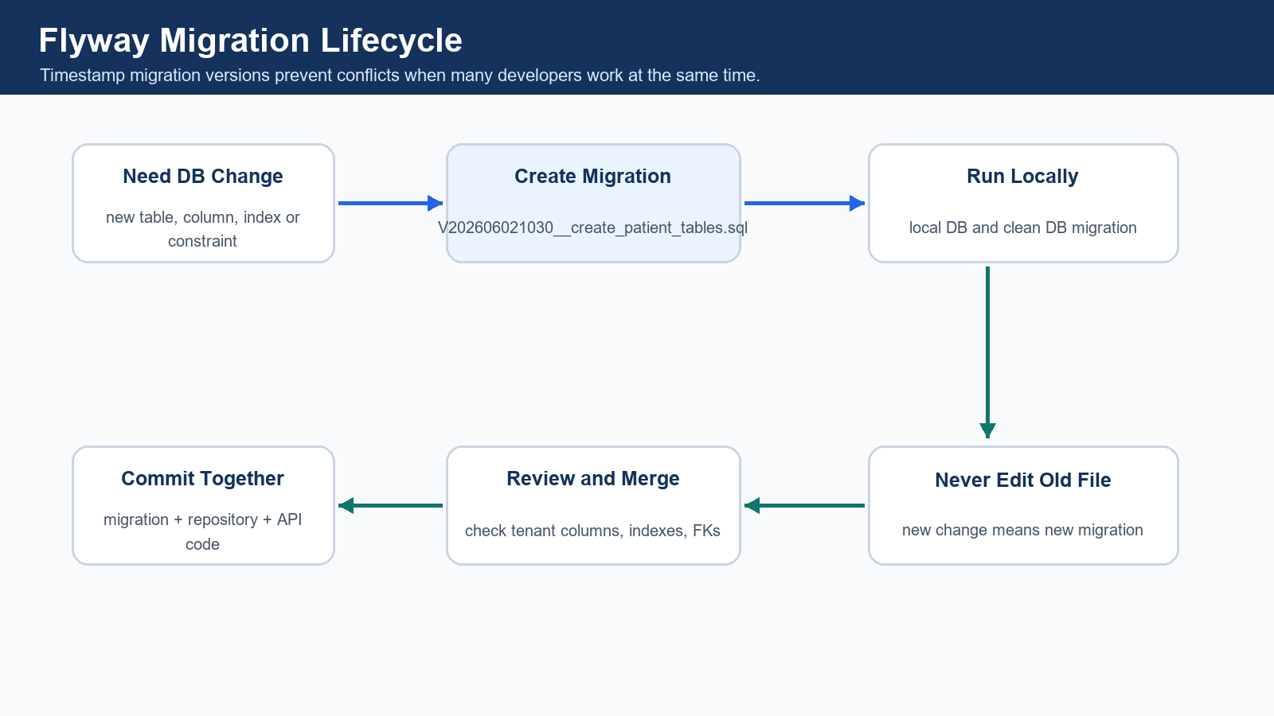
Flyway migration lifecycle.
Recommended migration tool: Flyway
- Flyway is simple, SQL-first, easy for JDBC projects, and practical for Spring Boot services.
- A migration tool is mandatory because database structure must be versioned like code.
- Direct manual DB changes are not allowed because they are not repeatable, reviewable or deployable.
- Every schema change must be committed with the related module code.

Style | Example | Recommendation
Sequential version | V001__create_foundation_tables.sql | Good for initial planning but conflict-prone with many developers.
Timestamp version | V202606021030__create_patient_tables.sql | Recommended for parallel development.
Repeatable seed | R__seed_default_roles_permissions.sql | Use for controlled master/reference seed data.

- Every developer must create a unique migration version using current timestamp.
- Never edit an already merged migration file.
- If a change is needed after merge, create a new migration file.
- Migration files must be small and module-specific.
- Seed data must be separate from schema migration.
- Rollback plan must be mentioned in the PR description.
- Always test migration on a clean database before PR.

8. Migration Folder Structure
src/main/resources/db/migration/
V202606020900__create_foundation_tables.sql
V202606021000__create_patient_tables.sql
V202606021100__create_appointment_tables.sql
auth-service/src/main/resources/db/migration/
hospital-service/src/main/resources/db/migration/
patient-service/src/main/resources/db/migration/
appointment-service/src/main/resources/db/migration/
lab-service/src/main/resources/db/migration/
billing-service/src/main/resources/db/migration/
pharmacy-service/src/main/resources/db/migration/
fhir-gateway-service/src/main/resources/db/migration/
hl7-integration-service/src/main/resources/db/migration/

- Each microservice owns its migration folder.
- Shared foundation schema should be owned by foundation or hospital service.
- Cross-service tables should be avoided unless architect-approved.

9. Git Branching Strategy
Branch Type | Example
Feature | feature/db-patient-schema, feature/db-lab-orders, feature/db-billing-invoice, feature/db-fhir-mapping
Fix | fix/db-patient-index, fix/db-appointment-tenant-filter
Hotfix | hotfix/db-payment-constraint

Step | Developer Workflow
1 | Pull latest dev branch.
2 | Create feature branch.
3 | Create unique Flyway migration file.
4 | Run migration locally.
5 | Add repository, service and API code.
6 | Test using Postman.
7 | Commit code and migration together.
8 | Push branch.
9 | Create pull request to dev.
10 | Review and merge.
11 | Team pulls latest dev and runs migrations locally.

10. Commit Message Convention
feat(db): add patient registration tables
feat(db): add lab order and result tables
fix(db): add missing tenant index on billing invoices
refactor(db): rename lab sample status column
chore(db): add seed data for appointment statuses

11. Pull Request Checklist
Checklist Item | Required
Migration file added | Yes
Migration file has unique timestamp version | Yes
Local migration tested | Yes
No direct DB manual change | Yes
All major tables have tenant_id, hospital_id and branch_id | Yes
Audit columns added | Yes
Indexes added | Yes
Foreign keys reviewed | Yes
Soft delete column added | Yes
Status columns standardized | Yes
Sample data separated from schema migration | Yes
API query has tenant filtering | Yes
Postman tests passed | Yes
FHIR mapping updated if applicable | Yes
HL7 mapping updated if applicable | Yes
No duplicate table created | Yes
No existing migration edited | Yes
Rollback notes added | Yes

12. Database Review Process
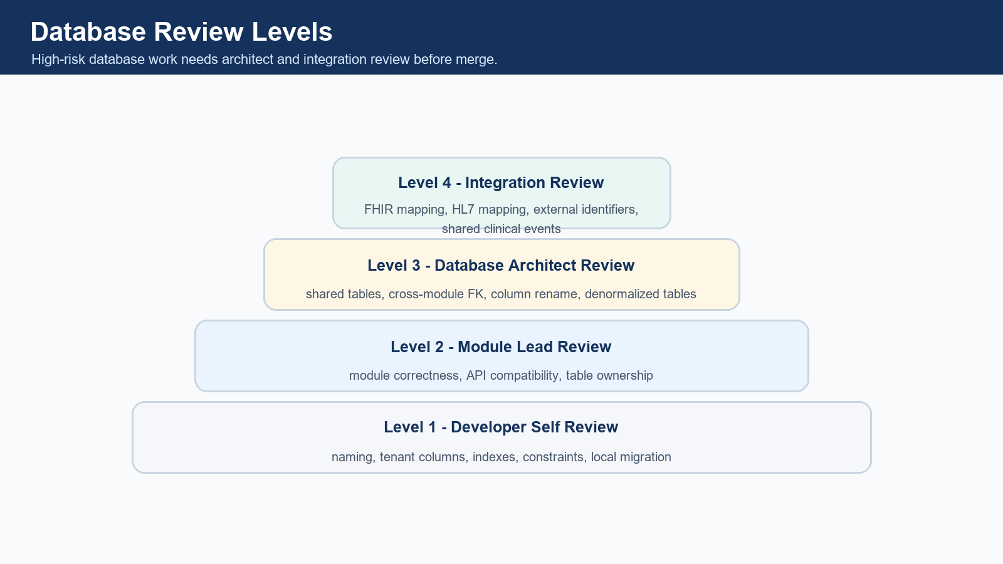
Four database review levels.
Review Level | Owner | Checks
Level 1 | Module Developer | Naming, columns, tenant isolation, indexes, constraints, migration run.
Level 2 | Module Lead | Module correctness, API compatibility, table ownership.
Level 3 | Database Architect | Shared tables, column rename, cross-module FK, multi-tenant logic, large index, denormalized table.
Level 4 | Integration Review | FHIR resource mapping, HL7 message storage, external system mapping, shared identifiers.

13. Conflict Prevention Rules
Common Conflict | Prevention
Two developers create same migration version | Use timestamp-based migration versions.
Two developers create same table | Use ownership matrix before starting work.
One developer changes shared table | Require architect approval.
Column name mismatch | Use naming convention and review checklist.
Missing tenant filters | Repository review and multi-tenant tests.
Broken foreign key | Integration testing on clean DB.
Heavy reporting query | Use denormalized summary table.
Migration works locally but fails in dev | Always test on clean DB before PR.

14. Local Development Database Strategy
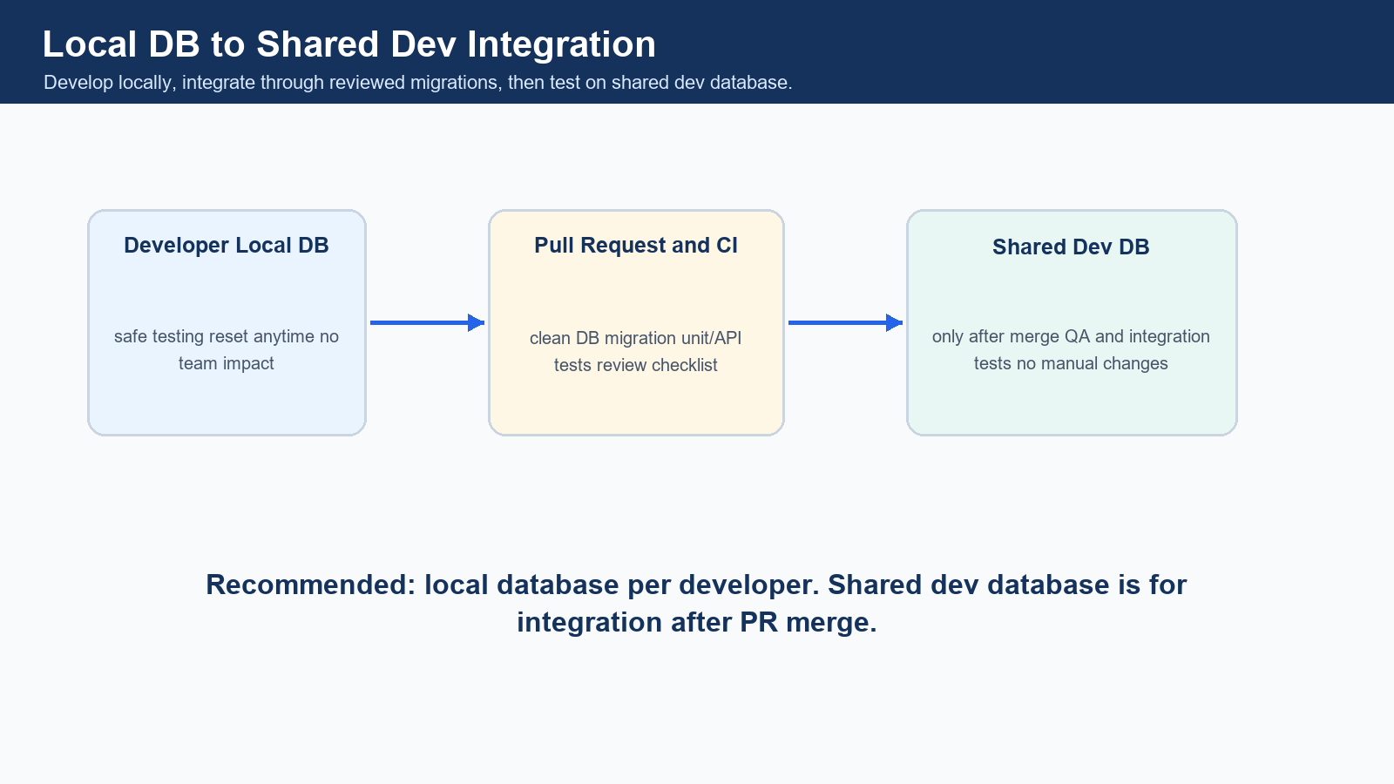
Recommended local-to-shared DB workflow.
Option | Recommendation | Pros | Cons
Local DB per developer | Recommended | No conflict, easy reset, safe testing | Each developer must keep migrations updated.
Shared dev DB | Use after PR merge only | Good for integration and QA | Can break others if direct changes happen.

15. Seed Data Strategy
- Master seed data should be separate from schema migration.
- Do not insert random test data in schema migration.
- Use Flyway repeatable migrations for controlled master data.
- Seed data should be reviewed because it affects all developers and environments.
R__seed_global_master_data.sql
R__seed_fhir_code_systems.sql
R__seed_default_roles_permissions.sql

Seed Area | Examples
Common master | gender_master, blood_group_master
Workflow master | appointment_status_master, encounter_type_master
Integration master | fhir_resource_type_master, hl7_message_type_master
Security seed | default_roles, default_permissions

16. Tenant Isolation Rules
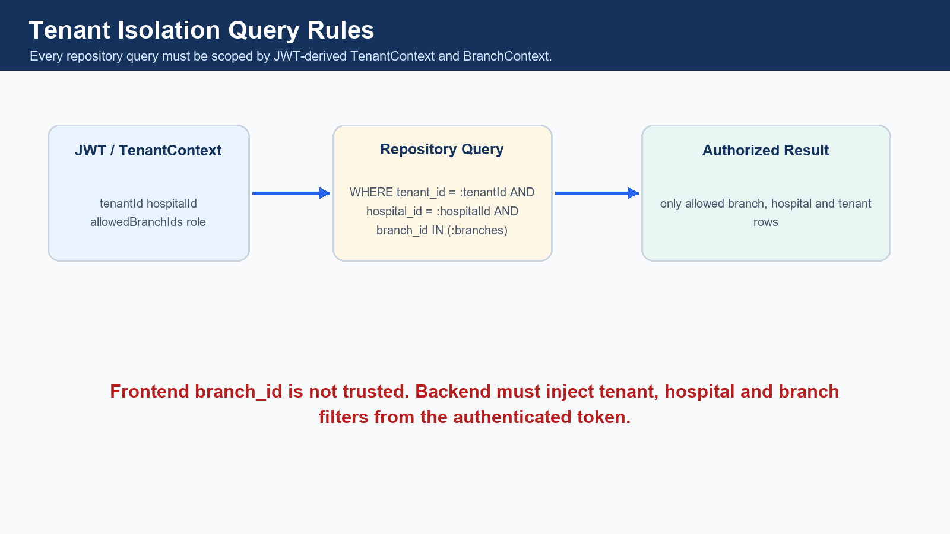
Tenant and branch isolation must happen in backend repository queries.
- All patient, clinical, billing, pharmacy and lab records must have tenant_id, hospital_id and branch_id.
- branch_id is mandatory for branch-level operations.
- Patient can be hospital-level.
- Encounter must be branch-level.
- Billing must be branch-level.
- Lab order must be branch-level.
- Pharmacy stock must be branch-level.
- No query should fetch data without tenant filters.
SELECT *
FROM patients
WHERE tenant_id = :tenantId
AND hospital_id = :hospitalId
AND is_deleted = 0;
SELECT *
FROM appointments
WHERE tenant_id = :tenantId
AND hospital_id = :hospitalId
AND branch_id IN (:allowedBranchIds)
AND is_deleted = 0;

17. FHIR and HL7 Responsibility Distribution
FHIR/HL7 Team Owns | Module Developers Must Provide
fhir_resource_mapping | Internal table name
fhir_resource_store | Internal record ID
fhir_api_audit_log | Business identifier
hl7_message_log | FHIR resource mapping requirement
hl7_mapping | Event triggers for create/update/status change
external_identifier_mapping | External system identifier rules

Module | Must Inform FHIR/HL7 Team
Patient | patients -> Patient, patient_allergies -> AllergyIntolerance, patient_documents -> DocumentReference
Lab | lab_orders -> ServiceRequest, lab_results -> Observation, diagnostic_reports -> DiagnosticReport
Pharmacy | prescriptions -> MedicationRequest, medicines -> Medication, pharmacy_dispense -> MedicationDispense
Billing | billing_invoices -> Account, invoice items -> ChargeItem, claims -> Claim

18. Inter-Module Dependency Flow
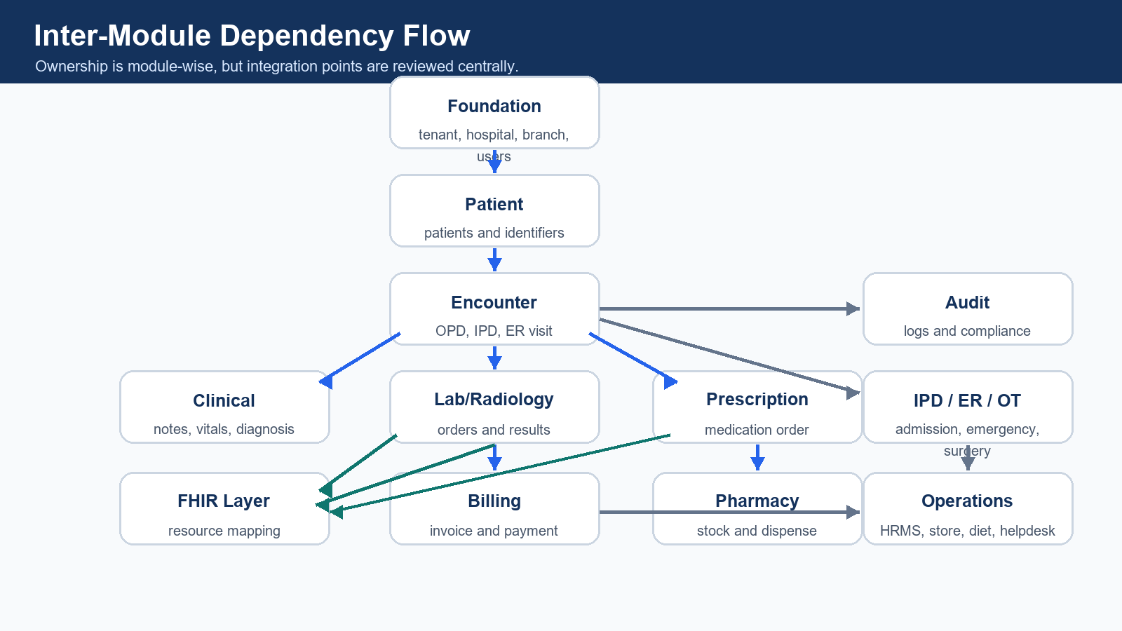
Module dependency flow.

19. Developer Daily Workflow
Time | Actions
Morning | Pull latest dev; run migrations locally; check conflicts; confirm assigned module tables.
During development | Create feature branch; add migration file; run app locally; test API; add indexes; add tenant filters; add audit events.
Before PR | Run clean DB migration; run module APIs; verify tenant isolation; verify branch isolation; update documentation; add PR checklist.
After merge | Pull dev; run migration; resolve conflicts early; notify team if shared table changed.

20. Integration Testing Workflow
Test Type | Scenario
Clean database migration | All migrations run from empty database.
Module API test | Postman collection passes for module endpoints.
Multi-tenant test | Hospital A cannot see Hospital B patient.
Multi-branch test | Branch A receptionist cannot see Branch B appointment.
Role test | Hospital admin can see all branches; branch user sees only own branch.
Encounter test | Patient visit creates encounter correctly.
FHIR mapping test | Lab result maps to Observation; prescription maps to MedicationRequest.
HL7 message test | Inbound ORU or ADT message is logged, parsed and mapped.
Reporting test | Summary table refresh works after transaction data changes.
Performance test | Large table query uses correct composite index.

21. Database Documentation Process
- Every module developer must update table list.
- Every new column should have a short description.
- FHIR mapping must be documented for mapped clinical, patient and billing tables.
- API mapping should describe which endpoints use the table.
- Index list and dependency list must be maintained.
docs/database/schema-overview.md
docs/database/module-table-ownership.md
docs/database/fhir-mapping.md
docs/database/hl7-mapping.md
docs/database/migration-history.md

22. Example Module Distribution Plan
Sprint | Developer Assignments
Sprint 1 | Developer A: tenant, hospital, branch, department, users, roles and permissions. Developer B: patient/MPI, patient contacts, appointment slots and queues. Developer C: encounter base, OPD queue, doctor workbench skeleton, vitals and diagnosis base. Developer I: FHIR base mapping tables. Developer K: audit log and consent foundation.
Sprint 2 | Developer C: full clinical EMR, notes, problem list, allergy, care plan, clinical orders and prescription. Developer D: lab order, sample, result and radiology report tables. Developer E: medicine master, batch, pharmacy stock and dispensing. Developer F: billing invoice, payment, refund and insurance claim base. Developer G: IPD admission, ward, bed and nursing tasks.
Sprint 3 | Developer G: discharge summary, follow-up, medication administration and nursing handover. Developer H: emergency, triage, OT, surgery, ambulance and blood bank. Developer L: staff attendance, HRMS, inventory store, procurement, diet, housekeeping, maintenance, helpdesk and portals. Developer I: HL7 inbound/outbound logs and external identifier mapping. Developer J: reporting summary tables and patient journey command center.
Sprint 4 | Developer J: analytics, AI alerts and operational risk summaries. Developer K: notification templates, delivery logs, break-glass access logs and patient record access logs. All module owners: FHIR/HL7 mapping review, tenant isolation test, branch isolation test, clean DB migration test and final integration hardening.

23. Definition of Done for Database Work
- Migration file created.
- Migration runs on clean database.
- Table follows naming convention.
- Tenant columns added.
- Audit columns added.
- Required indexes added.
- Repository queries have tenant filters.
- API tested.
- Postman collection updated.
- FHIR mapping documented if applicable.
- HL7 mapping documented if applicable.
- PR reviewed and merged.

24. Anti-Patterns to Avoid
- Manual database changes.
- Editing old migration after merge.
- Creating table without tenant_id.
- Creating table without indexes.
- Using random status values.
- Using varchar for money.
- Storing amount in floating type.
- Duplicating patient data in every module.
- Directly using frontend branch_id without backend validation.
- Building dashboards from heavy transactional queries.
- Mixing FHIR JSON as the main transactional table.
- Ignoring audit logs.
- Creating foreign keys without understanding module ownership.

25. Final Recommended Workflow Summary
Implementation recommendation
- Use local database per developer.
- Use Flyway timestamp migration files.
- Use module ownership matrix before creating or changing tables.
- Use shared dev database only after PR merge.
- Never make manual database changes.
- Use tenant_id, hospital_id and branch_id isolation in all tables and queries.
- Use normalized transactional tables and denormalized reporting tables.
- FHIR and HL7 should be handled by a dedicated integration team.
- Database architect reviews shared tables and cross-module changes.
- PR checklist is mandatory for every database change.

